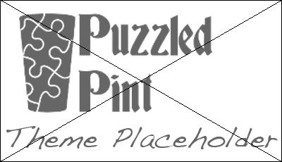

Title (Dakota, 18-32pt)

- Dakota font (for title) available in the Puzzled Pint Dropbox “assets” folder.
- Puzzle goes here.
- All conventions are flexible depending on needs of your puzzle.
- Versions should be uploaded to Dropbox in the month's folder
  - PDF for printed puzzles
  - MP3 for audio
  - MP4 (and/or Youtube) for video)
  - Name the file “AuthorInitials_PuzzleName_Status[_hints/solution]”
    - Status is “draft”, “qc”, or “final”
    - Example 1: Brian Enigma wrote a puzzle called “Generics”. The first draft is named “be_Generics_draft.pdf”.
    - Example 2: The solution is named “be_Generics_solution.pdf”
- If location puzzle:
  - Include a write-in answer line that points to the solution URL, such as: http://www.puzzledpint.com/puzzles/december_2013/drinks/_________
  - Also include some boilerplate text that this is the location puzzle and what to do with the answer, such as: “This is the location puzzle for Puzzled Pint on January 14th, 2014. For more information, visit: http://www.puzzledpint.com”

Author: Name (Location)

Solutions

- Solution is in a separate file from the puzzle.
- Typically, this is red text overlayed on the puzzle.
- If your puzzle uses a different format (audio, video, assembly, etc.), then feel free to write the solution in a format that makes more sense for your puzzle's format.
- PDF preferred. Text format okay.

